NOTES: The War of 1812

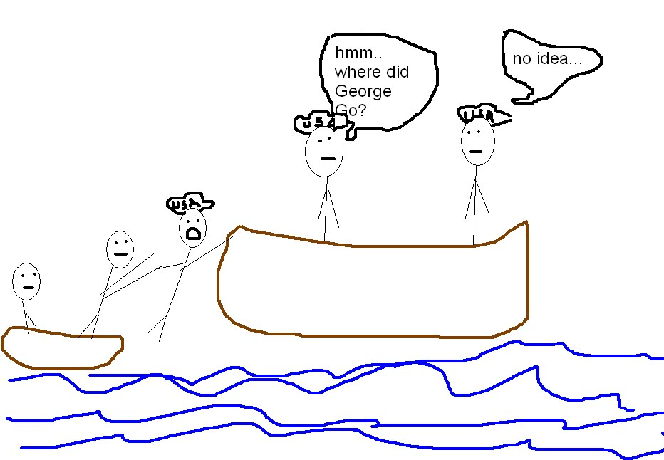
CAUSES of the WAR:
- Under Presidents Adam and Jefferson, __________________ of American ships and the __________________________ of American soldiers by Britain and France continued to be an unsolved dilemma. (see picture of impressment to the right)
- In 1809, when President James _____________________ took office, he realized that France and Britain would never stop attacking American ships unless he took _________________________ (extreme) action.
- Madison also suspected that the British were supplying weapons to the Native Americans living in the ____________________________________—as the Northwest Ordinance allowed Americans to expand westward to settle that region, Native Americans _____________________________ U.S. settlers using the British weapons. Madison knew he needed to put an end to the British supply of weapons to Natives Americans who continued to attack U.S. settlers.

CHECK your UNDERSTANDING: What were TWO major causes of the War of 1812? ___________________ __________________________________________________________________________________________________________________________________________________________________________________________________________________________________________________________________

EVENTS of the WAR:
- Madison decides to abandon the policy of _________________________________ and declare war on Britain on July 17, 1812. This began the War of 1812.
- After a series of battles, the powerful _________________________of the Native American tribes, Tecumseh, was killed in battle and this ended the ______________________ of tribal attacks against U.S. settlers in the Ohio Valley.
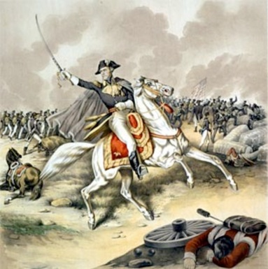
- The British troops attacked Washington, D.C., and destroyed the newly built ___________________. The war continued on to the final Battle of _________________________________________. General Andrew _____________________________ defended the city with his militia troops and successfully defeated the British army—2,000 British troops were killed in battle, while only 20 Americans lost their lives. This battle launched Andrew Jackson to the status of “________________________________.”
- Americans met with the British and signed a peace treaty in 1815, officially ____________________ the War of 1812.

