Narrative of the Life of Frederick Douglass:
An American Slave, 1845
Excerpts: Chapter 1

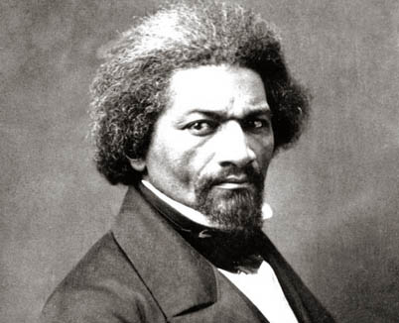
1 I was born in Tuckahoe, near Hillsborough, and about twelve miles from Easton, in Talbot county, Maryland. I have no accurate knowledge of my age, never having seen any authentic record containing it. By far the larger part of the slaves know as little of their ages as horses know of theirs, and it is the wish of most masters within my knowledge to keep their slaves thus ignorant. I do not remember to have ever met a slave who could tell of his birthday. … The white children could tell their ages. I could not tell why I ought to be deprived of the same privilege. I was not allowed to make any inquiries of my master concerning it. He deemed all such inquiries on the part of a slave improper and impertinent, and evidence of a restless spirit. The nearest estimate I can give makes me now between twenty-seven and twenty-eight years of age. I come to this, from hearing my master say, some time during 1835, I was about seventeen years old. …

2 I never saw my mother, to know her as such, more than four or five times in my life; and each of these times was very short in duration, and at night. … I do not recollect of ever seeing my mother by the light of day. She was with me in the night. She would lie down with me, and get me to sleep, but long before I waked she was gone. Very little communication ever took place between us. Death soon ended what little we could have while she lived, and with it her hardships and suffering. She died when I was about seven years old, on one of my master's farms, near Lee's Mill. I was not allowed to be present during her illness, at her death, or burial. She was gone long before I knew any thing about it. …

3 I have had two masters. My first master's name was Anthony. I do not remember his first name. He was generally called Captain Anthony—a title which, I presume, he acquired by sailing a craft on the Chesapeake Bay. He was not considered a rich slaveholder. He owned two or three farms, and about thirty slaves. His farms and slaves were under the care of an overseer. The overseer's name was Plummer. Mr. Plummer was a miserable drunkard, a profane swearer, and a savage monster. He always went armed with a cowskin and a heavy cudgel. I have known him to cut and slash the women's heads so horribly, that even master would be enraged at his cruelty, and would threaten to whip him if he did not mind himself. Master, however, was not a humane slaveholder. … He was a cruel man, hardened by a long life of slaveholding. He would at times seem to take great pleasure in whipping a slave. I have often been awakened at the dawn of day by the most heart-rending shrieks of an own aunt of mine, whom he used to tie up to a joist, and whip upon her naked back till she was literally covered with blood. No words, no tears, no prayers, from his gory victim, seemed to move his iron heart from its bloody purpose. The louder she screamed, the harder he whipped; and where the blood ran fastest, there he whipped longest. He would whip her to make her scream, and whip her to make her hush; and not until overcome by fatigue, would he cease to swing the blood-clotted cowskin. I remember the first time I ever witnessed this horrible exhibition. I was quite a child, but I well remember it. I never shall forget it whilst I remember any thing. It was the first of a long series of such outrages, of which I was doomed to be a witness and a participant. It struck me with awful force. It was the blood-stained gate, the entrance to the hell of slavery, through which I was about to pass. It was a most terrible spectacle. I wish I could commit to paper the feelings with which I beheld it.

Guiding Questions
Use the excerpts from Chapter 1 of the Narrative of the Life of Frederick Douglass to answer the questions below. You may have to re-read the message 3-4 times and look up any unfamiliar words.

BEFORE READING: Sourcing/Contextualizing
- Who wrote this document? When was it written?

- Based on what you know about Douglass and the time period, why do you think he wrote this book?

CLOSE READING: Life as a Slave
- In paragraph 1, why did slaves’ masters not want them to know information like their own age?

- In paragraph 3, how does Douglass describe his first master and overseer?

- In paragraph 3, what is the event that struck Douglass “with awful force”?

AFTER READING: Contextualizing/Corroborating
- How do you think Douglass’ descriptions of punishments for slaves affected his readers, especially white readers in both the North and South?

The Liberator
Inaugural Editorial by William Lloyd Garrison
January 1, 1831

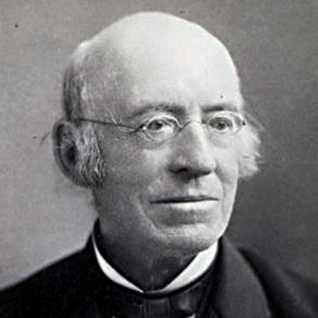
TO THE PUBLIC:

1 In the month of August, I issued proposals for publishing "The Liberator" in Washington City; but the enterprise, though hailed in different sections of the country, was palsied by public indifference.

2 During my recent tour for the purpose of exciting the minds of the people by a series of discourses on the subject of slavery, every place that I visited gave fresh evidence of the fact, that a greater revolution in public sentiment was to be effected in the free States -- and particularly in New-England -- than at the South. I found contempt more bitter, opposition more active, detraction more relentless, prejudice more stubborn, and apathy more frozen, than among slave-owners themselves. Of course, there were individual exceptions to the contrary. This state of things afflicted, but did not dishearten me. I determined, at every hazard, to lift up the standard of emancipation in the eyes of the nation, within sight of Bunker Hill and in the birthplace of liberty. That standard is now unfurled; and long may it float, unhurt by the spoliations of time or the missiles of a desperate foe -- yea, till every chain be broken, and every bondman set free! Let Southern oppressors tremble -- let their secret abettors tremble -- let their Northern apologists tremble -- let all the enemies of the persecuted blacks tremble. …

4 Assenting to the "self-evident truth" maintained in the American Declaration of Independence, "that all men are created equal, and endowed by their Creator with certain inalienable rights -- among which are life, liberty and the pursuit of happiness," I shall strenuously contend for the immediate enfranchisement of our slave population. …

5 I am aware that many object to the severity of my language; but is there not cause for severity? I will be as harsh as truth, and as uncompromising as justice. On this subject, I do not wish to think, or to speak, or write, with moderation. No! no! Tell a man whose house is on fire to give a moderate alarm; tell him to moderately rescue his wife from the hands of the ravisher; tell the mother to gradually extricate her babe from the fire into which it has fallen; -- but urge me not to use moderation in a cause like the present. I am in earnest -- I will not equivocate -- I will not excuse -- I will not retreat a single inch -- AND I WILL BE HEARD. The apathy of the people is enough to make every statue leap from its pedestal, and to hasten the resurrection of the dead.
Guiding Questions
Use the excerpts from William Lloyd Garrison’s editorial in the first issue of The Liberator to answer the questions below. You may have to re-read the message 3-4 times and look up any unfamiliar words.

BEFORE READING: Sourcing/Contextualizing
- Who wrote this document? When was it written?

- Based on what you know about Garrison and the time period, why do you think he wrote this article?

CLOSE READING: Feelings about Slavery
- In paragraph 1, what is the “state of things” in the country that is bothering Garrison?

- In paragraph 4, why do you think Garrison quotes the Declaration of Independence?

- In paragraph 5, what does Garrison mean by “The apathy of the people is enough to make every statue leap from its pedestal, and to hasten the resurrection of the dead”?

AFTER READING: Contextualizing/Corroborating
- Why would the abolition movement need both Frederick Douglass and William Lloyd Garrison as leaders?

Impertinent: rude; disrespectful
Overseer: someone who oversees, or manages, the plantation
Palsied: frozen; made unable to move
Detraction: taking away from; damaging the reputation of [slavery]
Apathy: not caring about anything
Afflicted: bothered
Emancipation: freedom
Spoliations: destruction
Foe: enemy
Abettors: helpers; partners [usually to a crime]
Northern apologists: people in the North who made excuses for the South’s use of slavery
Enfranchisement: the right to vote
Equivocate: be unclear or confusing
Hasten: speed up

